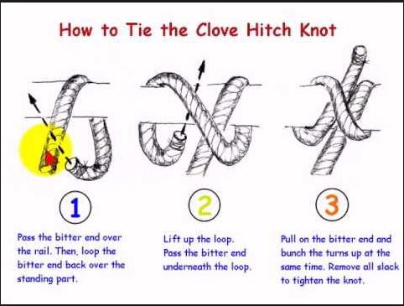
Clove Hitch A simple all-purpose hitch. Easy to tie and untie. A useful and easy to tie knot, the Clove Hitch is a good binding knot. However, as a hitch it should be used with caution because it can slip or come undone if the object it is tied to rotates or if constant pressure is not maintained on the line.
