Intro: Sawyer Reminder Training for LTC Camp. We will be bucking

Our desire: You would learn how to do sawyer/swamper/clean-up work in a safe way so that your good works would glorify our Father in heaven as we serve people.

“We don’t want people saying “These Cadet guys are strong and hard-working, and really served us with good attitudes, but they sure are wild and dangerous or they sure get hurt a lot!”

You can’t be productive if your saw is broken or under a log!

Unskilled work hinders the delivery of the Gospel message.
Skilled work enhances the delivery of the Gospel message. Titus 2:10

Pray: for safety and effectiveness in all situations!

Basic Terminology:

Kerf = the gap or notch left open after a saw has cut.

Bucking = to cut up a downed tree into sections

Chain Saw Basics

Q: How fast is a chain saw?
A: Over 600 teeth/second and over 45 mph!

Q: What happens if we forget to mix the oil with fuel?
A: Lots of friction! Cost of repair is huge!

Get to know your specific saw by reading the manual!!

Chain Saw Parts

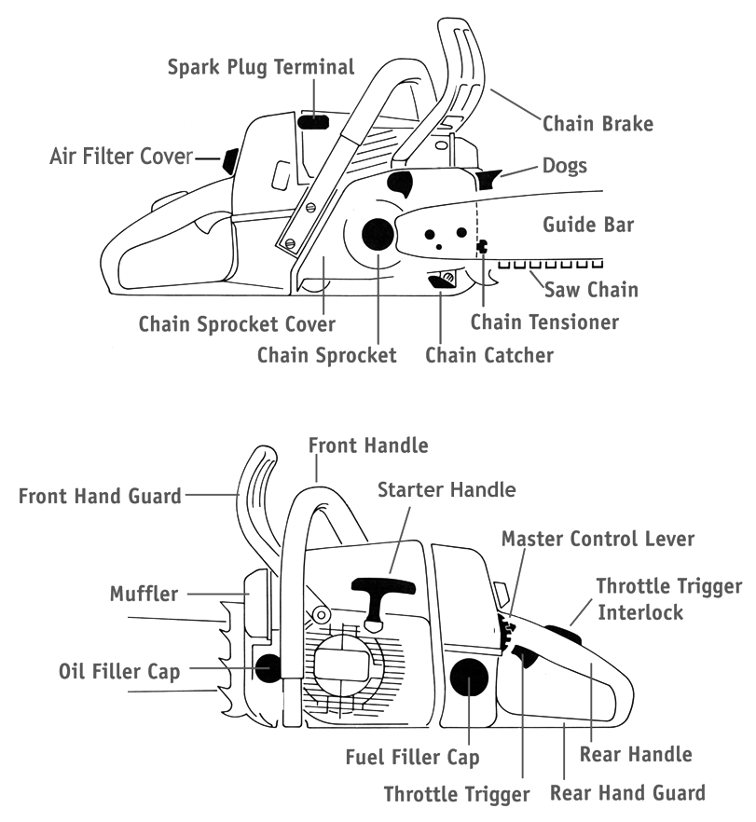

Common Dangers in the Log Lot

NEVER use a chain saw alone!

Note: Accidents happen even to careful, experienced people.

Q: What are the most common injuries?
A: Most common injuries: left thigh, back of left hand
A: Rolling trees, people get pinned under, or get struck by rolling branches
A: hot mufflers. They can reach temps of up to 900 ºF!

Q: Why do 80% of injuries with chain saws affect the hands and the legs?
A: One-handed use
A: Overly aggressive cutting
A: Fatigue
A: Lack of knowledge and experience

Let’s not be part of these statistics!

You should be scared/prayerful/alert/wary/concerned when operating a saw.

Prov. 19:2 “It is not good to have zeal without knowledge, nor to be hasty and miss the way.”

Personal Protective Equipment (PPE)

Q: As an Alert Cadet, what protective equipment do we need to us when sawyering?
A: Eyes, head (face) and ears: Chain saw helmet with hearing protection
NOTE! Helmets diminished peripheral vision. Be aware!!
A: Leg protection: Chaps
  - Chaps have 5 layers of Kevlar which grab the chain and slow in down quickly.
A: Feet: Heavy Boots
A: Hand protection: Gloves
A: Our stamina: Water, snacks

NOTE! All of this gear should be worn by swampers as well!

Helmet and all PPE adds to the perceived professionalism of workers.

Reminder on Safe Operation

Proverbs 22:3 and 27:12 says, “A prudent man sees danger and takes refuge, But the simple keep going and suffer for it.”

Pray! I Thess. 5:17 “Pray without ceasing”

Physique:

- NEVER run a chain saw alone! Always have someone with you. By nature, accidents are unplanned events. No one plans a problem.
  - Be in good physical shape. (PT!!)
- Take a break at the first sign of fatigue! Fatigue is the number one cause of most accidents

Place:
- Maintain a safe operating area: note by-standers, obstacles, valuable objects
- Consider which way the logs will roll when they are released.
- Watch out for hidden hazards like rocks under brush.

Chain saw operation:
- Make sure the saw is in good working order before you start.
- Firmly grip the saw, and wrap your thumb around the bar.
- Only step forward when chain has stopped moving.
- Shut the saw off or engage brake when moving debris.
- Do not over-reach or get off balance. (Don’t over-commit)
- Maintain control of the bar; You must know where the bar is and where it is going.
- The saw is designed to be used at full throttle.
- Stand to the side of the line of cut.
- Do not cut too high. The saw’s power head should be below shoulders.
- Engage the chain brake when walking around the work site.
- Keep distance between your legs and the saw. Avoid crossing over.
- Use the bumper spikes as a pivot point

Reminder Tension + Compression

Tension = pulling apart, like a tug-of-war rope
Compression = pushing together
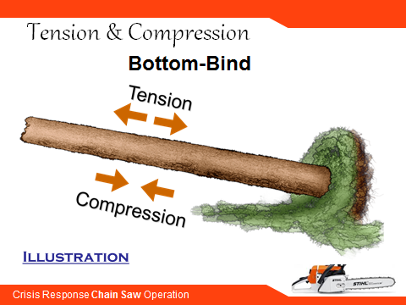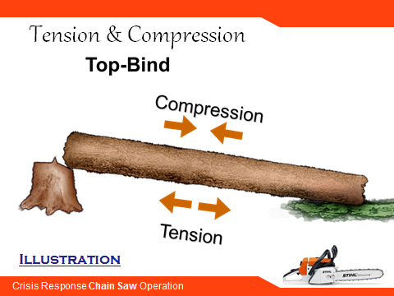

There is tension on the log/tree. As you cut into it you are going to experience the dynamics of these forces. Avoid pinching the bar and chain.
Sense when compression is starting to close the kerf, and pull out before you are fully pinched!

Kickback

Kickback is one of the greatest saw hazards. It occurs when a force throws the saw rapidly and
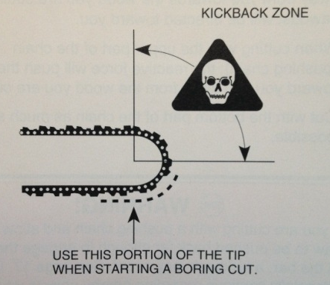
sometimes uncontrollably towards you. It is a very violent and sudden motion which can severely or fatally injure you. There are several causes:
- an abrupt change in wood character -- hitting a knot or a nail
- striking a nearby limb with the tip of the moving chain while cutting
- running the chain too slowly
- twisting the saw in your cut so the chain grabs
- using a dull or loose chain
- having a loose grip on the saw or cutting with only one hand
- not paying attention

But kickback can be prevented by a few steps and precautions on your part. These DO NOT PREVENT kickback completely, but they do reduce the possibility of it happening to you.
- Always hold the saw firmly with both hands and keep the left arm as straight and stable as possible
- Use a saw equipped with a chain brake, anti-kickback chain, or other anti-kickback devices.
- Do not rely exclusively upon safety devices.
- Watch for twigs that can snag the chain -- the area should be free from any obstructions.
- Cut with the lower part of the saw blade, not with the tip or nose.
- Maintain a high saw speed when entering, cutting and leaving the wood cut.
- Keep the chain sharp.
- DO NOT cut above mid chest height – the saw is too close to your face.
- DO NOT cut brush or shrubbery.

Sharpening

The chain is going to get dull, sooner or later!

Eccl: 10:9-10 “If the ax is dull, and one does not sharpen the edge, then he must use more strength; but wisdom (skill) brings success.”

If the chain is dull, stop and sharpen it, or change the chain.
You need to become proficient at sharpening if you are going to run a saw. Or have someone in your unit specialize in a deployment situation.

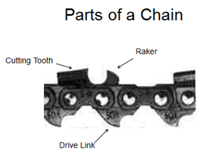
Understanding how a cutter works helps you see how to sharpen + maintain.

When you sharpen:
- Wear gloves
- Be sure to be thorough, treating all cutters the same. If not the chain will run roughly, wear quickly, may break.
- Use proper sized round file, and file holder to maintain 90 degree angle.
- Mark the cutter you begin on. (perm. Marker)
- File from inside to outside, forward strokes only, one side then other.
- Rotate the file, clean it out periodically. Use sharp file.
- If cutters are unevenly sized, take it in to shop.

Depth gauges determine the height at which the cutter enters the wood, and thus the thickness of the chip removed. E.g. block plane
- Use filing gauge to check and adjust the height of the depth gauge teeth
- Depth gauge teeth will generally need filing after 3 sharpenings.
- File down the top of the depth gauge until it is level with filing gauge
- Take same amount off each gauge. Round off its leading edge.

Daily Maintenance

Chainsaws are pretty high maintenance.

- Air filter: Brush it off daily at least! Fine sawdust will clog it.
- Close choke to keep dust out of carburetor.
- Chain brake: make sure it works!
- Idle speed: make sure the chain is not spinning. Dust gets in mechanism.
- Check for loose fasteners.
- Cooling fins. (read the manual)
- Bar maintenance: The bar is softer than chain, wears faster.
- Describe the oiler system: pump, through oil hole, chain carries it around.
- Clean and flip the bar each time you file the chain.
- Inspect the bar thoroughly.
- Make sure the bar groove is clean.
- Re-install the bar and chain:
- Fit the chain to the bar, starting at nose, with teeth pointing forward!
- Insert chain drive teeth in groove of bar.
- Fit the bar over the studs, fit chain over sprocket.
- Engage the peg of tensioning screw in locating hole.
- Adjust the tensioning screw so there is very little chain sag.
- Install the sprocket cover with 2 bar nuts.
- Tensioning the chain properly:
- Hold the nose of the bar up, use scrench to adjust screw clockwise until the chain fits snugly up to underside of bar, should be able to spin chain freely, but not pull chain out of the groove.
- While holding bar nose up, tighten rear nut, then front.
Note! Check chain tension frequently!!
Note! When finished, loosen up chain tension to prevent damage to saw as it cools down.

The Role of the Sawyer
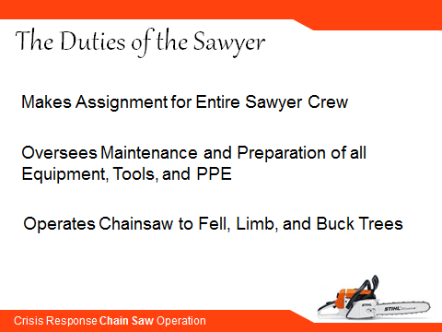
Dictionary: one who saws.
Discretion: The ability to avoid words, actions, and attitudes which could result in undesirable consequences.
Alertness: Being aware of that which is taking place around me so I can have the right response to it.

The Role of the Swamper

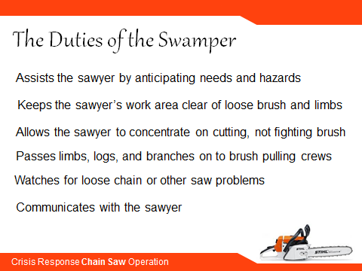
Dictionary: one who makes a path or clear an area by removing underbrush or slash as in logging
Sometimes also called a “safety”
Attentiveness: Showing the worth of a person or task by giving my undivided attention
This is very practical, and applicable to a lot of everyday situations!
Orderliness: Preparing myself and my surroundings so I (we) will achieve the greatest efficiency.
Alertness: Being aware of that which is taking place around me so I can have the right response to it.

