ALERT Cadet LTC Camp

Wilderness / Remote First Aid

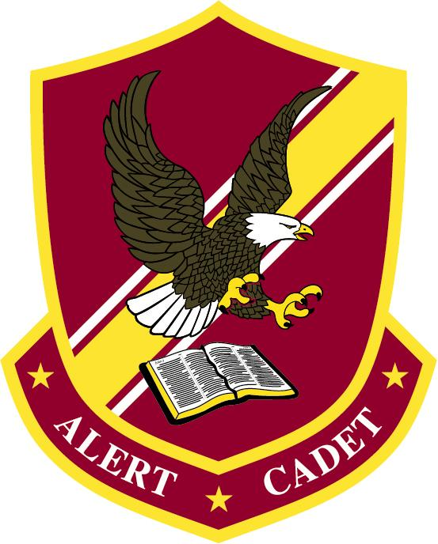

by CWO Mark Fields, EMT, WEMT
July 2021

Table of Contents
Section I: Introduction 4
1 – Why should we render aid? 4
2 – Provide Hope and Comfort 4
3 - Scene Safety 4
4 – Triaging 5
5 - PPE – Personal Protective Equipment 5
6 - Team Approach to Emergencies 5
7 - Activating 911 5
8 - First Aid Kits 6
Level 1 - Individual First Aid Kit (IFAK) / Trauma Kit 6
Level 1.5 – Boo-boo Kit 7
Level 2 – Basecamp Kit / Vehicle Kit / Squad Kit 7
Level 3 - Home Kit / Bug Out Kit 9
Section II: Patient Assessment and Initial Concerns 9
1 - Primary Assessment 9
Generation Impression 9
Alertness – AVPU 10
ABC / MARCH(E) 10
2 - Airway Management 10
Recovery Position 10
Head-tilt / Chin-Lift Maneuver 11
Jaw-thrust Maneuver 11
Rescue Breathing 11
Choking 11
3 – Cardiopulmonary Resuscitation 12
Cardiac Arrest 12
Adult CPR / AED 12
Child CPR / AED 13
Infant CPR / AED 13
4 - Bleeding 14
Types of Bleeding 14
Bleeding Control - Direct Pressure 14
Bleeding Control - Wound Packing 15
Bleeding Control - Tourniquets 15
5 – Shock 15
Type of Shock 16
Stages of Shock 16
Management of Shock 17
6 - Spinal Injuries 17
CSM – Circulation, Sensation, and Motion 17
Types of Injuries 17
Treatment for Suspected Injury 17
Lifting and Moving a Patient 18
7 - Evacuation / Patient Movement 18
Evacuation Considerations 18
Emergency Movements - Manually 18
Emergency Movements - Webbing 18
8 - Secondary Assessment 19
SAMPLE History 19
OPQRST 19
Monitoring Vitals 19
DOTS 19
Section III: Traumatic Injuries 20
1 - Head Injuries 20
Scalp Damage 20
Open Head Injury 20
Closed Head Injury 20
2 - Chest Injuries 20
Fractured Rib/Clavicle 20
Flail Chest 21
Closed Pneumothorax 21
Open Pneumothorax/Sucking Chest Wound 22
Hemothorax 22
Impaled Object 22
3 - Abdominal Injuries 22
General 22
Blunt Trauma 23
Penetrating Trauma 23
4 – Fractures 23
Types of Fractures 23
General Treatment 23
Upper Body Fractures 23
Lower Body Fractures 23
Complicated Fractures 24
5 – Dislocations 24
6 – Strains and Sprains 24
7 – Wound Management 24
8 – Amputations 25
9 – Burns 25
Section IV: Medical Emergencies 26
1 - Heart Attack 26
2 – Stroke 27
3 – Seizures 27
4 – Diabetic Emergencies 28
5 - Allergic Reactions and Anaphylaxis 28
6 - General Illnesses 28
Section V: Environnemental Emergencies 29
1 – Dehydration 29
2 - Heat-induced Emergencies 29
Heat Cramps 29
Heat Exhaustion 29
Heatstroke 29
3 – Cold-induced Emergencies 30
Heat Loss 30
Mild and Moderate Hypothermia 30
Severe Hypothermia 30
Frostbite 31
4 – Immersion/Submersion Incidents 31
5 – Lightning Injuries 31
6 – Bites and Stings 31
Snake bites 31
Insect bites and stings 32
Section VI: Common Issues 32
1 – Headaches 32
2 – GI Problems 32
3 – Blister 32
Section VII: References & Futher Training 33

Section I: Introduction

1 – Why should we render aid?
- ¹¹ Rescue those who are being taken away to death;
hold back those who are stumbling to the slaughter.
¹² If you say, "Behold, we did not know this,"
does not he who weighs the heart perceive it?
Does not he who keeps watch over your soul know it,
and will he not repay man according to his work? - Proverbs 24:11-12
- ³ Give justice to the weak and the fatherless;
maintain the right of the afflicted and the destitute.
⁴ Rescue the weak and the needy;
deliver them from the hand of the wicked." - Psalm 82:3-4
- ³³ But a Samaritan, as he journeyed, came to where he was, and when he saw him, he had compassion. ³⁴ He went to him and bound up his wounds, pouring on oil and wine. Then he set him on his own animal and brought him to an inn and took care of him. - Luke 10:33-37

2 – Provide Hope and Comfort
In an emergency situation, be a beacon of hope and comfort. You may be freaking out on the inside about the situation. Lean on your training, follow your protocols, and you will provide a huge amount of hope and comfort for your patient. You may not do everything 100% correctly, and that is OK. Be open and honest with you patient, do not lie to them about the severity of the situation!

3 - Scene Safety
What makes a scene safe? Slow down and observe a scene before entering it. Look for unusual sights, sounds, odors, or behaviors. Identify and take precautions with any hazards:
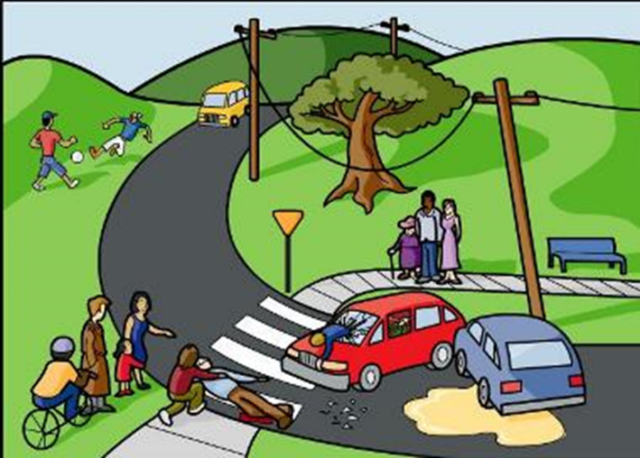
- Chemicals
- Needles
- Weapons
- Wires
- Vehicles
- Traffic
- Trees
- Buildings
- Other people

4 – Triaging
When multiple patients are on a scene, we need to triage the scene quickly and identify which patients are the priority. Promptly check each patient for life threats, then begin treating patients based on which life threats are highest. Hard decisions have to be made; use the facts before deciding who to care for first.

5 - PPE – Personal Protective Equipment
Ensuring you as the rescuer is safe is critical in an emergency. You do not want to create another victim. Each scenario can be unique in what equipment is needed to protect yourself. Our main concern in patient care is bloodborne and airborne pathogens. At a minimum non-latex gloves should be worn whenever making patient contact. Additional, safety glasses, masks, CPR mask, and/or a helmet may be needed. The footwear and clothing being worn should be adequate for the situation.

6 - Team Approach to Emergencies
Everyone has a role in an emergency; it takes a team of people to fill many roles. Even if you do not feel equipped to provide direct patient care, you can assist. Possible roles on a team:
- Leader/coordinator
- Patient care
- Communication – the person calling 911.
- Notetaker – gathering and keeping notes on patient information at times.
- Directing First Responders
- Managing crowd or family members
- Gathering additional equipment – AED, First Aid Kits, stretcher building, etc.
- Praying!!

7 - Activating 911
When calling 911, it is important to relay as much of the information as possible to the dispatcher. That information can be vital to ensure the right resources are coming to help. Basic information they are going to ask for:
- The location of the emergency
- The nature of the emergency: Fire, Police and/or EMS
- The telephone number being used.
- Your name.
- Number of injured or ill people
- What happened
- What helps, if any, has been given. And what trained people are on the scene.

8 - First Aid Kits
When talking about first aid kits, it is important to note that without training and practice, the items in your kit do not necessarily solve the emergency. They are tools we need to be familiar with and train in order to solve the emergency. Your greatest asset in an emergency is not your kit but a level head that can think and overcome the problems presented.
There are hundreds of opinions on what a first aid kit should or should not include. Below are three basic types of kits and suggested items. The important thing to note is that a kit should be built for specific reasons and be accessible. You should not carry items you are not trained to use (example, decompression needles)
Do not make a kit so big or bulking that it is not carried; keep it simple and concise!

Level 1 - Individual First Aid Kit (IFAK) / Trauma Kit
This kit should consist of extreme basic items for traumatic injuries. They must be quickly accessed. The main purpose of the kit is to quickly treat others until additional help can be obtained or quickly render self-aid. They may also be purpose-built and staged strategically. For example, carrying one on the belt of a set of Chainsaw champs so you or your swamper can render aid quickly in a severe hemorrhaging accident. Possibly want to consider a bag that is brightly colored and clearly marked.
Minimal Items:
- Commerce Tourniquet (CAT, SOFTT-W or SAM XT)
- Wound packing Gauze (with or without a hemostatic agent – Celox or QuickClot)
- Pressure bandage
- Non-latex Gloves
Optional Items:
- Trauma Shears
- Chest Seal / Exclusive Dressing
- Duct/Gorilla Tape
- Mylar Blanket
- Cravat/Triangle Bandages x 3
- 4x4 Gauze Sponges
- ABD Pads
- Rolled Cling or Cohesive Wrap (sometimes called Coband)
- Cloth Tape
- CPR Mask or Shield
- Band-Aids

Level 1.5 – Boo-boo Kit
I injected this kit in between because, depending on the scenario, you may want to carry additional items for comfort or to address small non-life-threatening injuries. This kit should be kept separate from the one above most suggest. It can be small enough to fit in a zip lock bag.
Possible Items:
- Band-Aids
- 4x4 or 2x2 Gauze Pad
- Moleskin
- Medications (pain, allergy, insect relief)
- Lip balm
- Electrolyte mix

Level 2 – Basecamp Kit / Vehicle Kit / Squad Kit
This kit should again be mission-specific, with the idea of the kit being to address multiple people and/or non-life-threatening emergencies. It should have all the items from Level 1 plus more. The items may be specific to the use at hand. For example, if the kit is in a bag for camping, it may include items for blisters from hiking or poison ivy. In contrast, a vehicle kit may not have those items.
Minimal Items:
- Duplicate of level 1 items for additional people.
- PPE – gloves, mask, safety glasses
- CPR Mask
- Hemorrhaging / Wounds:
  - Pressure bandage
  - 4x4 Sterile Gauze
  - ABD Combine Dressing Pads
  - Tape
  - Rolled Gauze
  - Band-Aids – various sizes
- Splinting:
  - Cravat/Triangle Bandages
  - SAM Splint (possibly multiple sizes)
  - Cohesive Wrap (sometimes called Coband)
  - Cotton Elastic Wrap (Ace Wrap)
- Emergency Blankets (at least 2)
- Medicines/Topicals:
  - Acetaminophen (Tylenol)
  - Ibuprofen (NSAID, Advil)
  - Aspirin
  - Loperamide HCl (anti-diarrheal)
  - Diphenhydramine (Benadryl)
  - 1% Hydrocortisone Cream
  - Antibiotic Ointment
  - Prescribed emergency medication (rescue inhalers, nitro, epi-pen, etc.)
- Diagnostic/Tools:
  - Rescue Knife / Window Punch
  - Penlight
  - Duct Tape
  - Sharpie Marker
  - Safety Pins
- Ziplock bags, empty

Optional Items:
- Cold/Hot Packs
- Electrolyte mix
- Lip Balm
- Moleskin or electrical tape
- Poison Ivy wash or ointment
- Creams, oils, or medicines to relieve discomfort (lotions, essential oils, etc.)
- Wounds:
  - Saline, optional with Irrigation Syringe
  - Wound closure strips.
  - Eye pads
  - Burn dressing.
- Diagnostic/Tools
  - Pulse Oximeter
  - Thermometer
  - Tweezers
  - Tic puller
  - Extra Batteries
  - Webbing – patient movement
  - Flashlight
  - Duct/Gorilla Tape (at least 10 feet)

Level 3 - Home Kit / Bug Out Kit
This should be your largest kit that is generally kept in a home or taken when having to evacuate home due to emergencies. Again, it should contain duplicates of the items above (2 is 1, 1 is none) and may include enough of something for each family member (example – emergency space blankets for each family member).
Possible Items:
- Diagnostic items
  - Pen Light
  - Pulse Oximeter
  - Blood Pressure Cuff (auto or manual)
  - Thermometer (should have more than one way to check temperature)
  - Otoscope
- Additional dressings/bandages
  - Take the healing process into consideration, multiple changes over time.
  - Consider a variety of types for different injuries.
- Cotton Elastic Wrap or braces (Ace wrap, wrist brace, knee brace)
- The bulk of your medications
- Items for dental emergencies

Section II: Patient Assessment and Initial Concerns

1 - Primary Assessment
Our primary assessment of a patient is where we identify life threats and prioritize addressing them. This is a critical step in assuring we are addressing needs correctly. Our assessment needs to be quick; we are focusing only on life threats here. Later we will do a more thorough assessment.

Generation Impression
This is a quick impression of the scene and patient. Trust your gut; does it look bad. This general impression will be the indicator of how quickly you must act. Listen to your patient, if they express they feel like they are going to die, take it seriously. Trust your gut (and the Holy Spirit), if you don’t feel good about the situation than act quickly.

Alertness – AVPU
We need to measure how alert a patient is using AVPU. The results should be noted with the time and should be monitored for change throughout the emergency. Any change in alertness should be noted with the time as well.
- Alert - The patient is fully awake (although not necessarily oriented). This patient will have spontaneously open eyes, will respond to voice (although maybe confused), and will have bodily motor function.
- Verbal - The patient makes a response when you talk to them, which could be in any of the three component measures of eyes, voice, or motor - e.g., patient's eyes open on being asked, "Are you OK?". The response could be as little as a grunt, moan, or slight move of a limb when prompted by the voice of the rescuer.
- Pain - The patient makes a response on any application of pain stimulus, such as a sternal rub, pinching the earlobe, or squeezing the fingers. A patient with some level of consciousness may respond by using their voice, moving their eyes, or moving part of their body.
- Unresponsive - the patient does not give any eye, voice, or motor response to voice or pain.

ABC / MARCH(E)
Traditional the ABC system has been taught. Airway, Breathing, Circulation in that priority order. Unless massive bleeding is occurring, then the priority is CAB. This can sometimes cause confusion, so the MARCH(E) system is better and more thorough:
- M = Mass Hemorrhaging - This is MASS bleeding; we are looking for large amounts of blood coming out of a person that is not controlled. We are not worried about bleeding that has stopped or is slowly trickling; those will be addressed later. We need to be able to see the site of the bleeding to address it.
- A = Airway - We need to ensure the airway is open for the patient. Depending on the injury/emergency, this may be the head tilt/chin lift, jaw thrust, or placing the person in the recovery position.
- R = Respiration - This is focused on breathing. If the person is not breathing, we need to take overdoing it for them. If they are having difficulty breathing, we need to assist them.
- C = Circulation - With circulation, we are first checking for a pulse; if not present, we are starting chest compressions. If a pulse is present, that we are focusing on shock. Ensure the person is lying down flat or in the recovery position and keep the person warm.
- H = Head Injury / Hypothermia -Do we have head or neck injuries that need to be managed. Is our patient cold (regardless of the season)?
- E = Evacuate – (Optional)

2 - Airway Management

Recovery Position
When an unconscious patient is left on his back, they may lose their airway due to relaxed tongue and/or vomiting. Patients should be rolled to their left side like pictured below. This will allow their airway to naturally remain open and help protect them from aspirating.
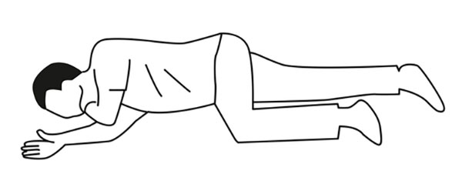

Head-tilt / Chin-Lift Maneuver
This method to open an airway is used when you do NOT suspect a head or neck injury. With one hand on the patient's forehead, apply enough pressure to tilt the head back. At the same time, lift the patient's chin with the fingers of your other hand. NOTE: Full extension could partially close the airway of a small child or infant.

Jaw-thrust Maneuver
If you do suspect a head or neck injury, utilize this method to open an airway. With your thumbs on the cheekbones and 2 or 3 fingers of each hand at the corner of the patient's jaw, lift the jaw with your fingers, using counter-pressure from your thumbs on the cheekbones.

Rescue Breathing
The air you inhale is approximately 21 percent oxygen, and the air you exhale is approximately 16 percent oxygen. So, with rescue breathing, you can provide adequate ventilation for a patient that is not breathing. Utilizing a mask, it highly recommended due to exposure to bodily fluids.
- Take a deep breath.
- Seal mouth around the mask.
- Deliver full, slow breaths. The breath should take about 2 seconds.
- Watch for chest rise and fall.

Choking

Adults
Perform the Heimlich maneuver (abdominal thrusts)
- Thumb side of the fist, above belly button
- Thrust in and up into the abdomen.
- Perform until the person can breathe, cough, speak, or becomes unresponsive.
- For larger people or pregnant women, utilize chest thrusts instead.
  - Fist on the lower half of breastbone.
  - Pull straight back.
- If the person becomes unresponsive, begin CPR.

Children
- Mild:
  - Can talk or make sounds.
  - Can cough loudly.
- Severe:
- Cannot breathe, talk, or make sounds.
- Has cough with no sounds.
- Makes the choking sign.
- Same as adult

Infants
- Mild:
  - Utilize child pads front and back.
  - If child pads are not available, use adult pads.
- Severe:
  - Cannot breathe or make sounds.
  - Has cough with no sounds.
- 5 Back slaps, with the heel of your hand
- 5 chest thrusts
- Continue until the infant is breathing.
- If the child becomes unresponsive, begin CPR.

3 – Cardiopulmonary Resuscitation

Cardiac Arrest
When cardiac arrest occurs, the quicker CPR starts and AED is applied, the higher the chance of survival. In the US, the average response time is 7 minutes, and in rural areas, it can be over 20 minutes. The civilian response is critical for the patient.
Minutes matter; for every minute delayed in CPR/AED, the survival rate decreases by 7 to 10%. By the 10-minute mark, death averagely occurs. However, God is amazing, and many cases are recorded where patients had survived when it was started greater than 10 minutes after occurring.

Adult CPR / AED
- Check for responsiveness – Tap and Shout!
- Call 911 and get an AED if possible.
- Check for Breathing.
  - If breathing but unresponsive, roll the patient to the recovery position.
  - If not breathing or gasping, begin CPR.
- Chest Compression
  - 2 inches deep
  - 100 to 120 compressions per minute
  - 30 compressions
  - Ensure chest rises between compressions.
- Rescue Breaths (Optional)
  - Ensure the airway is open.
  - Head tilt/chin lift
  - Jaw thrust – if suspected neck/spinal injury
  - 2 breaths for every 30 compressions
  - Watch for chest rise and fall.
- AED
  - Turn on.
  - Follow prompts.
  - Clear garments
  - Attach pads.
    - Consider body hair, jewelry, medication patches, pacemakers, and defibrillators.
  - If shock is advised, ensure everyone is clear before shocking.

Child CPR / AED
A child is considered 1 to 12 years of age. However, the size of a child must be considered. For children, cardiac arrest usually results from breathing problems.
- If alone, give 5 sets of 30 compressions/2 breathes before leaving to get help.
- Compressions are the same as an adult:
  - 2 inches deep
  - 100 to 120 compressions a minute
- AED
  - If 1 to 8 years old, utilize child AED pads; if not available, utilize adult pads
  - Older than 8 use adult pads

Infant CPR / AED
- An infant is considered a child under the age of 1 year old. Respiratory problems generally cause cardiac arrest.
- Check alertness by tapping the bottom of the foot.
- Careful opening the airway; unlike an adult, you can tilt the head too far and shut the airway off.
- Compressions
  - 100 to 120 compressions a minute
  - Depth 1.5
  - Use 2 finger or 2 thumb methods.
  - 30 compressions to 2 breaths, unless team then 15 compressions to 2 breaths
- AED
  - Utilize child pads front and back.
  - If child pads are not available, use adult pads.

4 - Bleeding

Types of Bleeding
- Capillary bleeding is slow, oozing, and is usually bright red in color.
- Venous bleeding comes out in a steady flow and can be a heavy flow if the injury is significant; it tends to be a dark maroon color due to the lack of oxygen.
- Arterial bleeding is under high pressure and is usually rapid, often spurting with each heartbeat. It tends to be bright red, even brighter than capillary blood.
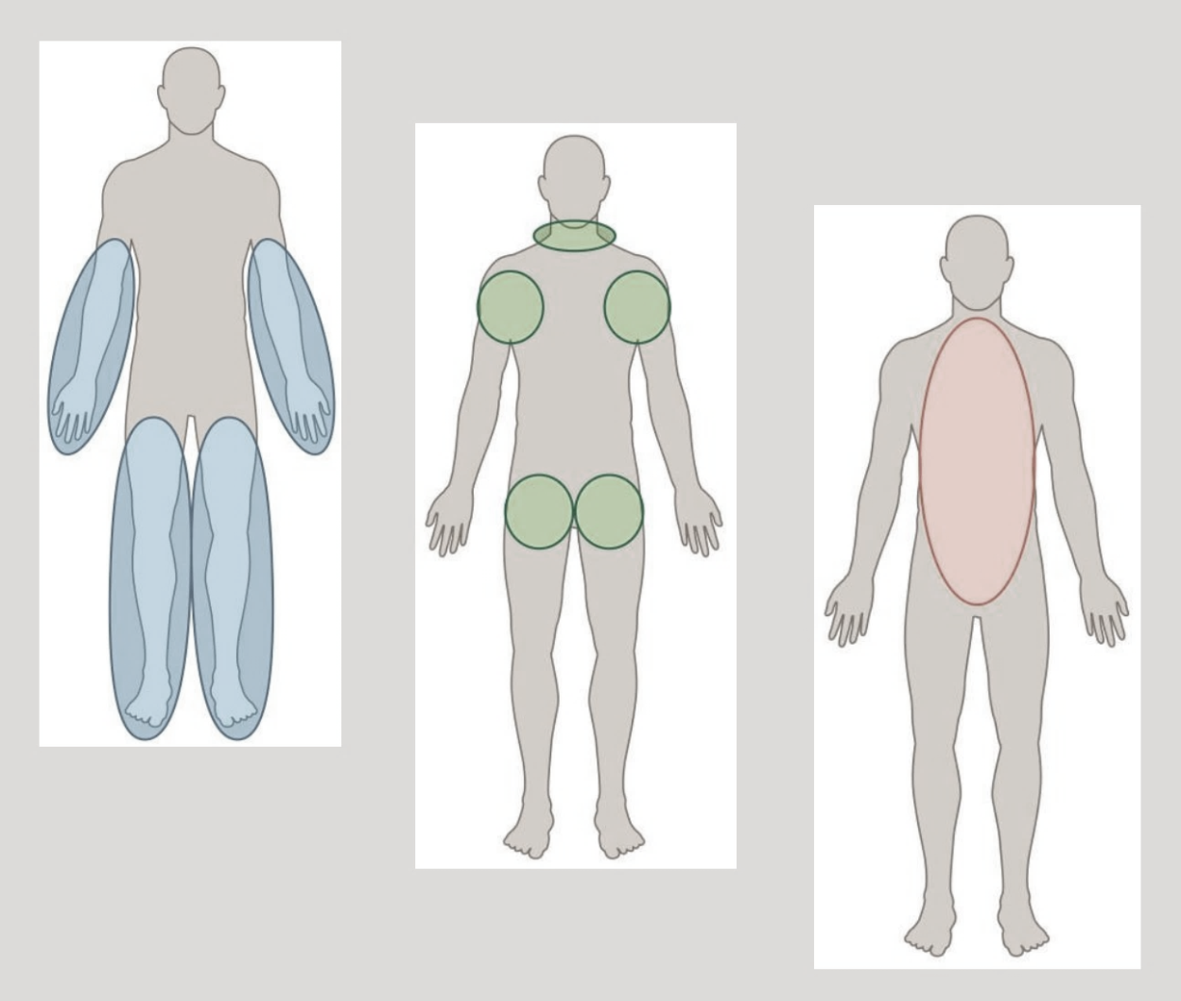

Bleeding Control - Direct Pressure
With most major bleeding direct pressure applied directly to the wound will stop the bleeding. Wearing gloves, apply pressure with the heel of your hand or the flats of your fingers, depending on the size of the wound. A sterile absorbent dressing should be utilized, but if not, available you can improvise with a t-shirt. If the bleeding continues, additional dressings should be applied. Do not remove the first dressing as clotting may have started to occur. For large wounds, you may need to pack the wound first before holding pressure. If you need a free hand, consider a pressure bandage. If the wound is on an extremity and bleeding cannot be controlled, apply a tourniquet.

Bleeding Control - Wound Packing
Wound packing is where we take sterile gauze and stuff it into a wound cavity. By tightly packing the wound, we are applying pressure into the wound. Ideally, we should utilize sterile wound packing gauze, possibly even one with a hemostatic agent like QuickClot or Celox. However, again a t-shirt can be improvised by being cut into strips 1 to 2 inches wide.
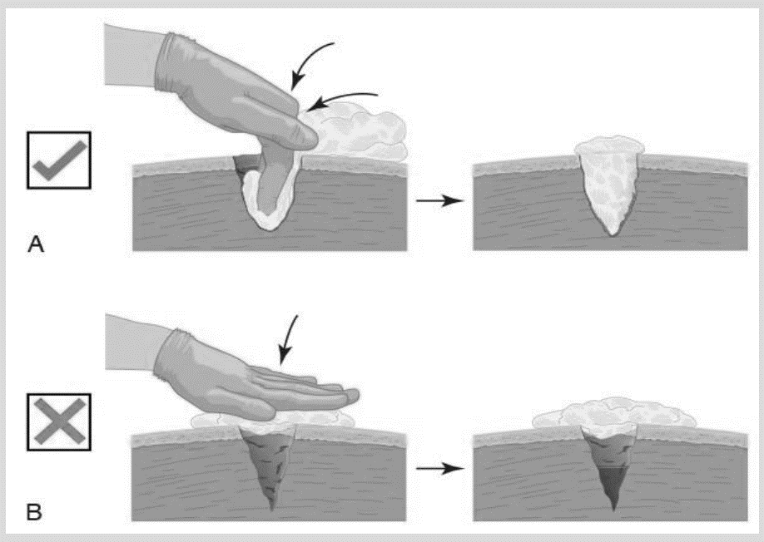

Bleeding Control - Tourniquets
Tourniquets can only be applied for wounds on arms or legs. They work by interrupting the blood flow to an extremity shutting all blood flow off. They are always applied above the wound. Once applied, the time needs to be written down on the patient or tourniquet and should NEVER be removed or loosed in the field. Tourniquets will hurt! Improvised tourniquets can be made, and we will demonstrate some, but given that they must be applied within seconds, commercial tourniquets are always the best option.

5 – Shock
Shock is the body's condition and reactions when tissues are not being adequately perfused with oxygenated blood. There are many things that can cause inadequate perfusion, but we will focus on the simplest forms. It is important to note that the type of shock is very difficult in the field to see, and a patient may have multiple forms of shock occurring. It is more important to identify the stages and manage the shock.

Type of Shock
- Cardiogenic Shock
  - Shock stemming from the failure of the heart could be caused by a heart attack or traumatic injury.
- Hypovolemic Shock
  - Shock occurring from a low volume of blood in the body. Bleeding may be internal or external.
- Vasogenic Shock
  - Shock resulting from the failure of blood vessels to maintain sufficient resistance to blood flow.
  - Septic Shock – shock stemming from an infection, the blood vessel can be damaged and leak
  - Anaphylactic Shock – stemming from blood vessels dilating and pressure to drop. However, the biggest concern is the swelling of the airway with this type of shock.

Stages of Shock
- Stage 1: Compensatory Shock
  - Bodie's attempt at managing on its own.
  - Signs and Symptoms
    - Anxiety; confusion
    - Rapid, strong pulse
    - Shallow, rapid respirations
    - Cool, clammy skin
    - Normal to pale complexion
    - Blood pressure in normal limits
    - Pupils are PERRL (pupils-equal-round-and-reactive-to-light)
    - Thirst, nausea, vomiting
    - Dizziness, lightheadedness, and/or weakness
- Stage 2: Decompensatory Shock
  - Bodie's attempt to manage are ineffective.
  - Signs and Symptoms
    - Altered level of consciousness.
    - Rapid, weak pulse
    - Rapid, shallow respirations
    - Cold, clammy skin (diaphoretic)
    - Very pale to cyanotic or mottled complexion.
    - Blood pressure dropping, with weakening radial pulse.
    - Pupils are sluggish to react.
- Stage 3: Irreversible Shock
  - The body has run out of options to manage the issue
  - Signs and Symptoms
    - Unresponsive
    - Extremely rapid heart rate
    - Slow, gasping breaths
    - Cold and damp or cold and dry skin
    - Blue or mottled appearance
    - Blood pressure and pulse undetectable
    - Pupils very slow to react or fixed and dilated.

Management of Shock
- Manage life threats that are causing the shock.
- Your calm attention may be all that keeps your patient alive; it relieves the anxiety and gives hope! Remain calm and remove all distractions that make the scene chaotic.
- Only move patient when it is critical.
- Keep the patient comfortable and warm.
- Evaluate the feet but no more than 10 inches.
- Monitor vitals every 5 minutes and note stage changes
- NOTHING by mouth is standard care, but in remote environments, you may administer SMALL amounts of water if the patient is conscious and alert.

6 - Spinal Injuries
Spinal injuries rack the most complicated and potentially devasting injuries. Proper management is critical, but this management can be made more difficult in remote or wilderness situations due to a lack of tools. Skilled handling and adequate equipment (even if improvised) are critical. We must treat all unconscious trauma patients as if they have a spinal injury until it is proven otherwise.

CSM – Circulation, Sensation, and Motion
This is the system we will use to assess good sensory, neurological, and motor functions.
- Circulation: Check the radial pulse in each hand and pedal pulse on each ankle—they should be equal on both sides. Another option is to check to see if their hands and feet are warm.
- Sensation: Gently squeeze one of the patient's fingers and toes toward the outside of each foot or hand and one toward the inside of each foot or hand and ask them to identify each digit in question.
- Motion: Ask your patient to move their fingers or toes and test grip strength by having the patient squeeze your hands.

Types of Injuries
- Uninterrupted Spinal Cord – No changes in CSM
- Partial Spinal Cord Injury – One or more changes in CSM
- Full Spinal Cord Injury – Obvious loss of CSM

Treatment for Suspected Injury
- Manually stabilize the head and neck, keeping the patient as still as possible. It may require moving the neck back into a neutral position, but only if it does not cause pain. Any movement MUST be very slow.
- Check for CSM
- Apply cervical collar, either commercial or improvised.
- Log roll them to backboard or rigid litter if possible.
- Pad void for patient's comfort
- Secure patient to backboard or litter, securing from feet to head
- Reassess CSM and adjust strapping if it changed.

Lifting and Moving a Patient
All patient lifts and movements are done as a unit; the person that is at the head or holding c-spine is the leader of that unit. Be clear and loud when giving commands: "On three we lift! Is anybody not ready? OK One, Two, Three"

7 - Evacuation / Patient Movement

Evacuation Considerations
With evacuations, we must consider the safety of our crew and patient. We do not want to harm ourselves (creating another patient) or cause additional harm to our patient. Below are some considerations when making a plan to evacuate.
- Neck or spinal injuries – Is there a suspected injury to the neck or spine that will limit our options for movement. However, if the patient is encountering immediate life threat of things like fire/smoke, we must move them quickly.
- Available resource – Do I have enough people or equipment to safely move the patient?
- Terrain – Can we safely move across the terrain?

Emergency Movements - Manually
For these movements, we are only going to be utilizing our body or possibly a sheet/tarp.
- Clothes Drag
- Foot Drag
- Blanket Drag
- Fireman's Carry
- Wheelbarrow Carry
- Four-hand Seat

Emergency Movements - Webbing
For these movements, we are going to utilize our standard length of webbing and do a water knot at the ends, creating a complete circle of webbing. Storing it with the knot in it allows for quick deployment of our webbing to move a person.
- Quick Harness – quickly goes under head and shoulders so the patient can be dragged.
- Hasty Harness – For having to lower a person down rope quickly.
- L Harness – Great for moving a person upstairs. Goes under one leg and across the chest like a 7.
- Halo Harness – Called this because the webbing circles around the patient as a halo.
- Quick Stretcher – Form a circle, cross middle sections forming 3 circles. Now have 6 handles for a team of people to carry patient. The crew member at the right side of the head makes calls when to move.

8 - Secondary Assessment
After our primary assessment and life threats are treated, we want to move onto a full head-to-toe secondary assessment. If it is a traumatic injury, we need to look or touch everywhere an injury could have occurred. Many times, a secondary injury can go unnoticed and be life-threatening.

SAMPLE History
If possible, for all patients, medical or trauma, we should attempt to get a SAMPLE history. This information will assist EMS when they get on the scene. They still may ask the same questions to verify the information.
- S = Signs and Symptoms
- A = Allergies
- M = Medications
- P = Past Pertinent medical history
- L = Last oral intake
- E = Events leading up to present illness or injury

OPQRST
When asking about Signs and Symptoms, you can use OPQRST to get more detailed information. Think like a detective and try to get all the information you can through questions.
- O = Onset of the event - What were you doing when the pain started?
- P = Provocation - What makes it better or worse?
- Q = Quality of pain – Can you describe the pain? Is it constant, throbbing, stabbing?
- R = Region and Radiation – Where is the pain? Does it radiate anywhere?
- S = Severity – Can you rate the pain from 0 to 10? Where 0 is no pain and 10 is the worse you have felt in your life?
- T = Time – When did the pain or illness start?

Monitoring Vitals
At the base level, we are only going to talk about taking two vitals on a person. However, if you do have access to some automatic tools like a Pulse-oximeter or an automatic blood pressure cuff, you can take additional vitals. Vitals should be recorded with the time and monitored every 5 to 15 minutes.
- Respiratory Rate – number of breaths per minute. Normal is 12 to 20 for an adult.
- Pulse - To check your pulse at your wrist, place two fingers between the bone and the tendon over your radial artery — which is located on the thumb side of your wrist. When you feel your pulse, count the number of beats in 15 seconds. Multiply this number by four to calculate your beats per minute.

DOTS
With DOTS, we are looking for physical injuries to the bodies and identifying them.
- D = Deformities
- O = Open Injuries
- T = Tenderness
- S = Swelling

Section III: Traumatic Injuries

1 - Head Injuries
Injuries to the head may or may not include scalp damage. Injuries to the brain may be closed (skull remains intact) or open (skull fractured and/or penetrated). All injuries to the brain require immediate attention. The term unconscious is often misused; remember, there are levels of consciousness, and we need to correctly assess using AVPU when dealing with a head injury. If an injury occurs from a fall, it's important to estimate the distance fell and if the patient was wearing head protection or not.

Scalp Damage
Laceration and avulsions to the scalp often bleed profusely at first, but rarely is serious, nor does it send a patient into shock. Bulky dressing should be used to stop any bleeding so that pressure is dispersed in case there is any fracture to the skull.

Open Head Injury
An open head injury is a fracture of the skull; the opening may not be visible. The following may be indicators of a skull fracture:
- Fracture lines visible beneath a tear in the scalp
- Deformity, often a depression, at the site of the injury
- Raccoon eyes – black-and-blue discoloration around swollen eyes
- Battle sign – black-and-blue discoloration behind or below the ears
- Seizures
- CSF (cerebrospinal fluid) or blood mixed with CSF leaking from the nose and/or ears.
Any fluids coming from the ear and/or nose should not be stopped as it could increase intracranial pressure. The patient needs to evacuate as soon as possible. Any object that penetrates the skull must be stabilized before moving.

Closed Head Injury
A closed head injury involves a period of unconsciousness often. No matter how minor the severity of the close injury, there will always be some damage to brain cells. The two determining factors in the priority of evacuation need to be the duration and depth of unconsciousness. If it was unwitnessed, we need to assume the worse. If evacuation cannot be performed immediately, the patient's consciousness needs to be monitored closely for changes and watch for changes to the injury site. Do not give pain medication during the evacuation as it can mask signs and symptoms.

2 - Chest Injuries
Any injury to the chest should be considered an immediate life threat until proven not so. Chest injuries can be open or closed injuries and can be the result of blunt, penetrated, or compression trauma. With chest injuries, we need to carefully monitor respiration rate and effort. Normal breathing is 12 to 20 breaths a minute.

Fractured Rib/Clavicle
Broken ribs and clavicles account for most chest injuries. Although very painful, they are rarely life-threatening. The patient will normally take shallow breaths, will often squeeze or press on site of injury to relieve pain. If spinal injuries are not suspected, the patient can be placed in a position of comfort. A sling-and-swathe technique or a pad secured to the chest may relieve much of the pain.

Flail Chest
If multiple ribs are broken, or the sternum is broken, a section of the chest wall may become free-floating, called a flail chest. A minor flail is subtle; however, a major flail can be life-threatening. The flail chest will often move in the opposite direction as the rest of the chest while breathing, called paradoxical respiration. If underlying lung damage also had occurred, a pneumothorax and/or hemothorax may occur (see below). Taping a bulky dressing securely over the flail may improve breathing for the patient, especially if the taping is midline to midline (halfway around the patient's body). Breathing should be monitored closely for changes.

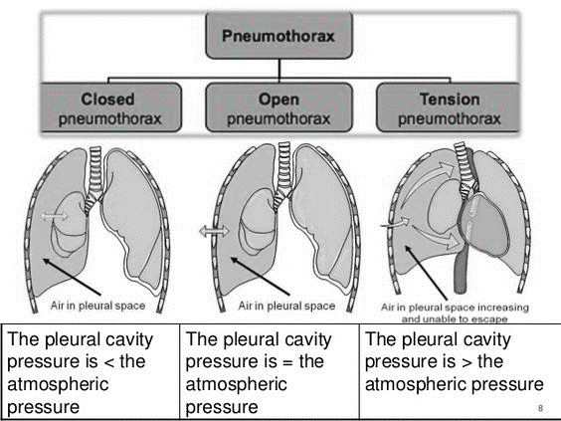

Closed Pneumothorax
A pneumothorax is a collapsed lung due to pressure changes in the chest cavity. The change can occur due to a puncture of the lung (closed pneumothorax), causing air to leak into the chest cavity on inhalation. Difficulty breathing will occur but often will reach a point where it will not get worse. Respirations need to be monitored as they can develop into a tension pneumothorax, eventually collapsing the lung and putting pressure on the heart. As pressure builds, it can cause Jugular Vein Distension (JVD), and the trachea may deviate towards one side. The patient should be kept in a semi-reclining position; immediate evacuation is needed.

Open Pneumothorax/Sucking Chest Wound
When the chest has been penetrated, a sucking chest wound may occur. Immediate action is required; plug the hole quickly with a finger. Cover the wound with an occlusive dressing, like a chest seal or plastic taped on 3 sides in hopes that air collecting under tension in the chest will self-release. If air does not release, it will develop into a tension pneumothorax, and under full tension pneumothorax, that patient will not be able to breathe. Death is imminent; you can push your little finger into the hole to attempt to release trapped air as a last attempt to save the patient's life.

Hemothorax
The chest cavity can also fill up with blood instead of air. Treatment should be the same as a pneumothorax. Additionally, with the blood loss, shock will need to be managed as well. This is an immediate life threat and requires evacuation as soon as possible.

Impaled Object
Do not remove any impaled object! Pad well around the object with the padding rising at least as high as the object and tape the padding in place to stabilize the object. Evacuation should be a high priority.

3 - Abdominal Injuries

General
When assessing abdominal injuries, we want to identify injuries based on quadrants. This helps assess which organ could possibly be injured. We should palpate each quadrant, starting with the one furthest from the injury, working towards the injury. We are looking for any deformities or guarding. Pain may occur on the pressing or releasing while palpated. All findings should be documented.
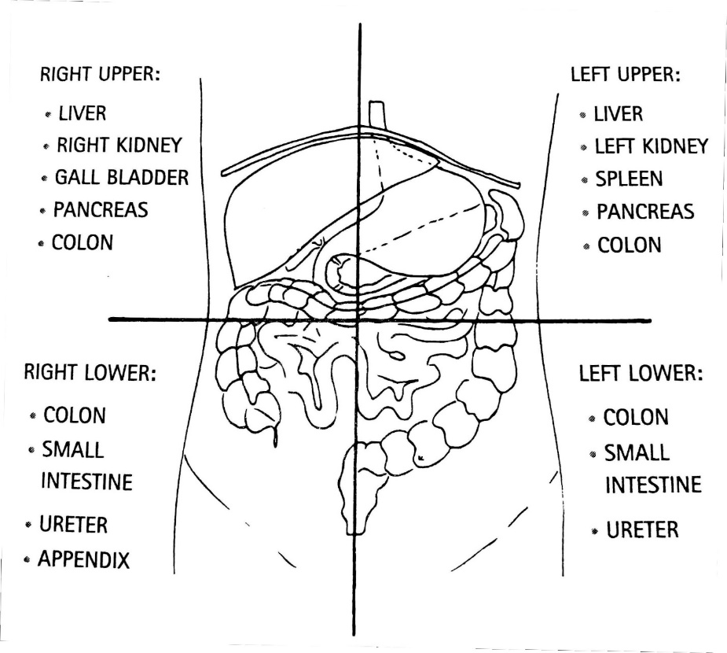

Blunt Trauma
A severe blow to the abdomen needs to be taken seriously. The signs and symptoms may not be obvious. It is important to note what hit the patient and how fast it was going. Hollow organs, when ruptured, may release substances into the abdomen. Likewise, solid organs, when ruptured, will bleed into the abdomen. The patient will often be most comfortable in a position with knees bent to take pressure off the abdomen. Assess for signs of shock and treat accordingly. Nothing should be given to the patient by mouth. During extended evacuations, a small sip of water may be given but nothing more.

Penetrating Trauma
How serious a penetrating trauma to the abdomen has a lot to do with which organs were injured and if serious bleeding is occurring. General treatment is the same as blunt trauma. Any external bleeding should be treated immediately. Any impaled object should be stabilized. If an evisceration (internal organs come outside the body) occurs, the organs should be covered with moist sterile dressings. Dressings should be assessed every 2 hours to ensure they continue to stay moist.

4 – Fractures

Types of Fractures
In the scope of this class, we are going to group fractures into two groups—open or closed fractures. Open fractures are where the skin is not intact; the bone does not necessarily have to be visible to be open. Otherwise, if the skin is intact, it is considered a closed fracture.

General Treatment
The general principle with all fractures is to splint and immobilize the injury. There should be adequate circulation, sensation, and motion before and after a splint is applied.
- Check CSM – circulation, sensation, and motion.
- Splint the injury in a position of function.
- Surround the injury site with padding.
- Support the injury site with something rigid.
- Immobilize the joints above and below a possible fractured bone or the bones above and below an injured joint.
- Check CSM.

Upper Body Fractures
For upper body fractures involving the arms, splinting should be applied, and then a sling and swathe used to secure the arm. The sling and swathe should also be used for shoulder, collarbone, and scapula fractures. For finger fractures, buddy splinting (splinting to adjacent fingers) will be sufficient. Padding should be placed between fingers for greater comfort.

Lower Body Fractures
Fractures to the hip, pelvis, and femur present major problems due to protentional of shock. Also, depending on the mechanism of injury, spinal injuries could be highly likely. Lower leg fractures, on the other hand, are generally not life-threatening. In the case of hip and/or pelvis fracture, we want to pad between the legs and splint legs to each other. For a pelvis fracture, we also want to secure padding around the pelvis to limit its movement. All other fractures can be splinted by the best means possible.

Complicated Fractures
With open fractures, we need to control any bleeding first. Any splinting performed should not be placed over the opening. If the bone is protruding, traction may need to be applied to align the bone before splinting. However, traction should be stopped if it increases pain or discomfort for the patient or if force is needed to align the bone.

5 – Dislocations
The reduction (putting a dislocation back in place) is going to be outside our scope of practice. If the patient can perform reduction on themselves quickly, then allow them to perform it if it is safe. However, the longer the time has passed since the dislocation, the harder reduction is going to be outside of a hospital. Place the patient in a position of comfort with the dislocation and possibly splint or sling the injury.

6 – Strains and Sprains
Strains are injuries to the muscle fibers and tendons, whereas sprains are injuries to the ligaments. Outside a hospital setting, we will not be able to assess the difference. Swelling will occur, CSM should be monitored. If possible, ice should be applied to reduce the swelling. Splinting or wraps may be applied for comfort if CSM is monitored.

7 – Wound Management
General wound care needs to focus on three goals: (1) control of significant blood loss, (2) prevention of infection, and (3) promotion of healing. Any allergies to latex or adhesive tape should be considered. Also, depending on the injury, tetanus immunization may be a concern. The immunization must be given within 72 hours of a wound for it to be effective.
In general, all wounds should be considered contaminated and therefore require cleansing in a remote or wilderness situation. The following technique can be utilized to clean wounds:
- Scrubbing: Disinfectants and soaps should not be put directly into wounds because they can damage viable tissue. These substances may be used to scrub around a wound prior to the cleansing of the wound directly.
- Irrigating: With adequate pressure and clean (disinfected for drinking) or sterile water, most wounds can be adequately cleaned out. An irrigation syringe works best, but a hole in a water bottle or a zip lock bag works just as well. Simply rinsing or soaking the wound may be inadequate to remove all bacteria. The wound should be tilted so all run-off moves away from the wound.
- Debriding: Deeply embedded, visible debris not removed by irrigation may be removed carefully with tweezers sterilized by either boiling or with an open flame.

8 – Amputations
With amputations, bleeding control is the priority. The wound should be irrigated and bandaged. Do not attempt to reattach the body part. If the detached body part can be safely recovered, it should also be irrigated and wrapped in a moist sterile dressing and brought with the patient to the hospital. If possible, it should be placed in a plastic bag and a cold pack on the outside of the bag.

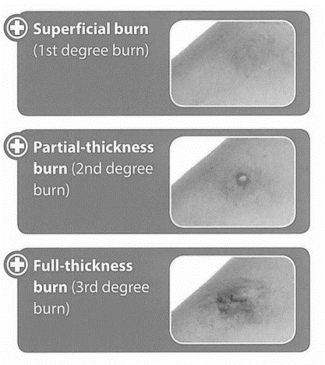
9 – Burns
STOP, COOL, and COVER. The critical first step is to stop the burning process; surprisingly, burns can continue to burn tissue for a while. Attempt to cool the burn with cool water, do not use cold water or ice. Be careful of the cooling process because hypothermia may occur. Do not try to remove anything stuck to the wound, like clothing or plastic. Do not pop any blisters! Cover the burn loosely with a dry sterile dressing.
The patient's palm is about 1 percent of their body's skin, arms, and head are 9%, legs, front and back of torso 18%. And partial or full-thickness covering 10 to 15% of the body calls for rapid evacuation. Great than 15% is a life threat.

Section IV: Medical Emergencies

1 - Heart Attack
A heart attack is a sudden blockage of blood flow to the heart. Without adequate blood flow, the heart muscles cannot get nutrients and oxygen it needs to function. Signs and symptoms:
Men:  Often, but not always, experience the "classic" signs and symptoms.  Chest Pain:  - Pressure, squeezing, tightness, aching, and/or heaviness.  - Last longer than 3-5 minutes  - Goes away and comes back.  - Radiating pain to arm(s), shoulder, and/or neck  Secondary:  - Dizziness  - Loss of consciousness  - Sweating  - Nausea  - Shortness of breath | Women:  May experience the "classic" signs.  Often milder than men  May be accompanied by more general signs and symptoms.  - Shortness of breath  - Nausea, vomiting, or diarrhea.  - Fatigue  - Dizziness  - Sweating  - Back or jaw pain
Treatment:
- Call 911
- Have the person stop what they are doing and rest.
- Loosen any tight clothing.
- Have the person take any prescribed medicine (e.g., nitroglycerin)
- Check the following before giving aspirin:
  - Are they allergic to aspirin?
  - Do they have a stomach ulcer or disease?
  - Are they taking any blood thinners?
  - Have they been told by a healthcare provider not to take aspirin?
  - Are they able to chew and swallow?
- Amount of aspirin to give:
  - Give 2 low-dose (81-mg) aspirin.
  - Or 1 regular-strength (325-mg) aspirin
- Note time aspirin was given and how much.

2 – Stroke
A stroke occurs when blood supply is interrupted or reduced to the brain. Quick and early action can reduce brain damage and reduce long-term effects. Assessing a stoke quick and taking actions to get EMS notified are critical. Signs and Symptoms:
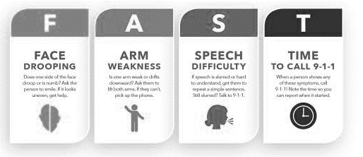
- Trouble with speech and language
- Drooling or difficulty swallowing
- Drooping features
- Trouble seeing in one or both eyes.
- Weakness
- Paralysis
- Sudden, severe headache
- Dizziness or loss of balance
- Confusion
- Loss of consciousness

3 – Seizures
Seizures can occur for countless reasons. While scary to watch, they usually last less than 2 minutes and have few if any complications that result from them. A seizure must run its course once it has begun, there is nothing you can do to stop it, but you can protect the patient from getting hurt. A patient can NOT swallow their tongue, so do not stick anything in their mouth. Evacuate or call 911 for any of the following occurs:
- A seizure lasts more than 5 minutes.
- The person is injured because of the seizure.
- The person is unresponsive, not breathing or gasping after the seizure.
- Pregnant or has diabetes.
- A young child and seizures were brought on by a high fever.
- Elderly person
- First seizure
- The seizure took place in water.

4 – Diabetic Emergencies
With a diabetic emergency, we are trying to determine is it hyperglycemia (high blood sugar) or hypoglycemia (low blood sugar). If the patient is alert, we can ask them questions like: When is the last time you ate? Have you taken any insulin today? Also, look for the following signs.
Hyperglycemia | Hypoglycemia
- Increased hunger, thirst, or urine output  - Fatigue  - Restless, "drunken" level of consciousness  - Weak, rapid heart rate  - Increase respiration rate  - Skin is warm, pink, and dry  - The breath odor is sweet. | - The level of consciousness may range from disoriented to irritable to combative to unconscious  - Seizures are possible  - Respiratory rate is normal or shallow  - Skin is pale, cool, and clammy  - Breath odor does not change.

Hyperglycemia can be complex; unless the patient can access and administer their own insulin, our treatment is going to be supportive: manage the airway, monitor vitals, and treat for shock.
With Hypoglycemia, if the patient is alert and able to swallow, we can administer some type of sugar. Simple sugars like a sugary drink or candy bars can help short-term, and complex carbohydrates like a peanut butter sandwich can help more long-term. If the patient is unconscious, we do not administer anything by the mouth and rapidly evacuate and call 911.

5 - Allergic Reactions and Anaphylaxis
Allergic reactions are caused by the excessive release of histamines and other substances in the body's immune system in response to the presence of an allergen. Small reactions can be as simple as running nose and itchy eyes, and large reactions can be life-threatening closing of an airway due to swelling. For small reactions, they can be treated with Benadryl or other over-the-counter allergy medicines. The most severe allergic reaction is known as Anaphylaxis.
Anaphylaxis may begin as a normal reaction but quickly results in respiratory and/or circulatory collapse. The resulting anaphylactic shock is from rapidly dilating blood vessels, which can completely close off an airway. It requires rapid intervention, and EpiPen is critical. Check with the patient if they have an EpiPen and assist in using it. Do realize the effects of epinephrine can wear off in as little time as 15 minutes, so monitor your patient closely until EMS arrives. A second dose of Epi may be required and can be given within 5 minutes of the first if conditions do not approve. It is also important to administer Benadryl (diphenhydramine) after Epi usage because it is slow reaction may help as the Epi's effect wears off.

6 - General Illnesses
For all other general illnesses, we need to lean heavily on our primary and secondary assessments. Trust your instincts; if you or the patient are not feeling comfortable with the situation, make contact with 911 ASAP and begin your evacuation plan. Focus on caring for the needs of the patient and provide assurance and comfort.

Section V: Environnemental Emergencies

1 – Dehydration
The average person at rest loses 2 to 3 liters of water a day. When perspiration occurs, that can increase by 1 to 2 liters a day. When the body is down merely 1.5 liters, your endurance may be reduced by 22 %, and oxygen uptake can be lowered by 10%. When down 3 to 4 liters, endurance decreases 50%, and oxygen uptake is down 25%. At that level, urine will have turned a dark yellow. Levels of dehydration are as follows :
- Mild: dry mucous membranes (lips and mouth), normal pulse, darker urine, and thirst.
- Moderate: very dry mucous membranes, rapid and weak pulse, darker urine, and thirst.
- Severe: very, very dry mucous membranes, an altered level of consciousness, no urine, no tears, and shock (rapid and weak pulse, rapid breathing, pale, dry skin).
Dehydration can occur at any temperature. A patient that is dehydrated only should take sips of water to replenish levels. Caffeinated drinks and alcohol will increase dehydration even quicker and must be avoided.

2 - Heat-induced Emergencies

Heat Cramps
Heat cramps are on the minor side of heat-induced emergencies. They are painful muscle cramps usually do to sweating, caused most likely by dehydration and lower levels of electrolytes. Treatment is to move to the shade, rest the painful muscle and rehydrate (possibly with electrolytes). Monitor the patient closely because it may be the first sign of heat exhaustion.

Heat Exhaustion
Heat Exhaustion occurs when the body is no longer able to cool itself due to loss of fluids. The patient may experience increased heart rate and respiratory rate, headache, dizziness, nausea, thirst, or fatigue. This patient must be moved to a cool place immediately, pouring water on their head and fanning them. Start rehydrating the patient with cool (not cold) water. Note that it will take over an hour to rehydrate 1L of water in the body. Treat the patient aggressively because it can quickly turn into a heatstroke.

Heatstroke
Heatstroke is a life-threatening emergency; a patient can die within 30 minutes. The body's cooling system is completely overwhelmed. Confusion, loss of consciousness, and seizures may occur. Skin will be hot, red, and dry; respirations will be rapid and shallow, and heart rate will be rapid and weak. Due to the core temperature increase in the body, cardiovascular and neurological collapse are imminent.
Treatment must be fast and aggressive. Active 911! Remove all clothing that could retain heat. Keep the patient wet and fan the body. Apply ice packs to the neck, groin, and armpits. Submerging the patient into cold water may be less effective, as it causes vasoconstriction, reducing the body flow throughout the body and slowing the cooling process. Rehydration may be difficult due to the conscious level of the patient. Do not give the patient any medicines. Rapid evacuation is a must.

3 – Cold-induced Emergencies

Heat Loss
As we talk about cold-induced emergencies, it's essential to understand the method in which the body loses heat so that we can combat hypothermia before or after it starts.
- Conduction – heat loss when a warmer object comes in contact with a colder object.
- Convection – heat loss directly to air or water as it moves by the body.
- Radiation – heat is given off by the warmest object in an environment, often our body.
- Evaporation – The process of a liquid changing into vapor; as the liquid evaporates, it removed heat from the object.

Mild and Moderate Hypothermia
Mild hypothermia is often described as the "umbles." The patient first stumbles, fumbles, grumbles, and later mumbles. Gross motor skills begin to be affected, then fine motor skills. The patient begins to draw inwards, and the thought process becomes impaired. Fine shivering begins, but the patient is able to control it. The main concern is the patient's inability to think clearly; they may start to make decisions that put them at greater risk of getting colder.
Moderate hypothermia is where the shiver is now violent and uncontrollable. The patient will increasingly become confused; heart rate and respiration rate will increase. Skin will be cold and pale.
Treatment for mild and moderate hypothermia is the same:
- Remove any damp clothing and replace it with dry clothing.
- Protect the body from wind and water.
- Add extra insulation around the patient: clothing, sleeping bags, etc.
- Provide the patient with water, preferably warm. But do not give caffeinated drinks or alcohol; they will make the condition worse.
- If the patient is alert, give them simple sugars and complex carbohydrates to fuel their inner fire.
- Provide heat packs, but not directly against the skin.
- Rescuers snuggling a patient have been found to provide little to no effect on the outcome for the patient, and in case studies have put the rescuer in danger themselves.

Severe Hypothermia
Severe hypothermia is characterized by increasing muscle rigidity and stupor, progressing to unconsciousness. The heart rate is slow and weak to the point it may not be detectable on the patient. Respiration rates will slow down and may not be detectable. Skin will be very cold and cyanotic. By all accounts, the patient will appear dead and yet be alive.
Do not rush or panic during treatment! Rough handling of the patient can cause a weak and slow heartbeat to stop. Take your time and be gentle with the patient. The main priority for the patient is oxygen. If they are unconscious, we may need to breathe for them for 3 to 15 minutes before moving them.
Our patient needs to be placed in a hypothermia wrap, a cocoon to protect against heat loss. Prepare your cocoon before moving the patient to limit their movement. Cut all clothing that is wet or cold off the patient, do not try to pull it off. Heat packs may be utilized in the cocoon, just not directly against the bare skin. Evacuate the patient and activate 911 as soon as possible.

Frostbite
Frostbite is tissue damage from freezing. Just like burns, we are going to categorize them as superficial, partial-thickness, and full-thickness frostbite. It is important that we only attempt to warm a body part if we can assure it will stay warm during the evacuation. If not, we should not attempt to warm it as refreezing will cause even more damage. Also, any trauma to the site should be avoided; the tissue is very brittle. Come up with a plan before attempting to warm the body.
Superficial frostbite will appear reddish, warm area with other warm body parts. Do not rub it or apply strong radiate heat; it will cause tissue damage. Partial-thickness frostbite skin will appear white, waxy, numb, and cold to the touch. The affected area should be warmed by submersion in warm water. Blisters will form after warming. Full-thickness frostbite will be pale white in color and feel almost "wooden." Rewarming will be extremely painful for the patient and should be accomplished the same as partial-thickness. After warming, the tissue should be wrapped with dry sterile dressing; wrap each toe and finger individually.

4 – Immersion/Submersion Incidents
Immersion/submersion incidents carry a higher risk to a rescuer than any other rescue incident. The water that threatens the life of your patient may suddenly threaten your own life. We are going to use the Reach, Throw, Row, Tow, and Go method to rescue our patient:
- Reach – for the patient with your arms, legs, sticks, or clothing from a safe position
- Throw – throw something that floats
- Row – access the person via a boat if possible and safe to do so
- Tow – pull the patient to safety via what you threw or rowed with if possible
- Go – last resort is going to be swimming to the patient.
If the patient has drowned and recovered, begin rescue breathing for the patient. If no pulse is present, also begin CPR. Expect the patient to vomit; when they do so, roll them to their side to clear their airway. If the patient is revived or if the patient experience any water in the airway, they must seek medical treatment immediately – dry-drowning can still occur later. We also need to consider hypothermia, regardless of the time of year.

5 – Lightning Injuries
Injuries from lightning can occur from any or multiple mechanisms: direct strike, splash or side flash, contact with item strike, ground current, and blast effect. Types of injuries are often: cardiac arrest, respiratory arrest, neurological injury, burns, and blast injuries. Assess the patient fully to identify life threats; multiple may be present. Also, be aware of multiple patients, triage the scene before giving care. Ensure the safety of the team; lightning does strike twice in the same place and can injury multiple people at once.

6 – Bites and Stings

Snake bites
Death by venomous snake bites are infrequent, and in North America, most occur from pit vipers (rattlesnakes, copperheads, and water moccasins). Keep the patient calm and at rest. Remove any clothing or jewelry that may restrict blood flow as swelling starts—Mark on the body where the swelling is present and continue to monitor. Keep the patient hydrated and evacuate immediately. Do Not:
- Cut and suck the wound
- Give pain medication
- Apply ice
- Use a tourniquet

Insect bites and stings
We are going to group all bites and stings into one group. While spiders and scorpions are venomous, and can require more urgent evacuation, the techniques to treat them are all the same:
- Keep patient calm
- Monitor vitals for allergic reaction
- Clean the wound
- Apply cold to reduce the swelling
- Remove stinger or ticks
- Seek medical assistance or call 911 if any concerns arise.

Section VI: Common Issues

1 – Headaches
Headaches are a generic term meaning anything from mild discomfort to severe debility. Generally, headaches result from 1 or 2 of these three sources: dehydration, tension, and vascular problems. Pain medication can be administered, and the patient should stay hydrated. Any of the following should be a concern with a headache, and immediate medical help should be sought:
- A high fever
- Unusually stiff neck
- Experiencing series of headaches, each getting worse
- Any extremities that are weak, numb, or paralyzed
- Altered mental status

2 – GI Problems
With any GI issue causing nausea, vomiting, or diarrhea, we are concerned about dehydration and electrolyte imbalance. Ensure the patient continues to remain hydrated. Administer anti-diarrhea medicine if needed. The patient needs to be evaluated if you can't keep them hydrated or blood is present in vomit or stool.

3 – Blister
Technically a blister is a mild partial-thickness burn caused by friction. Blisters usually only form on the hard skin of the hands and feet. Softer skin would just form an abrasion from the rubbing. While there are many techniques to handle blisters, the main concept is the same. We need to relieve the pressure in the blister as sterile as possible, clean the wound and dress the wound in a way that will limit any more friction to the site. Moleskin and electrical tape are often used to do so.

Section VII: References & Futher Training
The following material was used as references to develop this training. If you wish to learn more about this topic the following material would be great references.
American Red Cross – Wilderness and Remote First Aid: Emergency Reference Guide
NOLS – Wilderness Medicine Institute: Wilderness First Responder 3rd Edition by Buck Tilton
WMS/ECSI/AAOS – Wilderness First Aid 4th Edition
AAOS – Emergency Care and Transportation fot he Sick and Injuried 12th Edition
AAOS – Emergency Medical Responder 7th Edition

Hands on training is always the best way to further your skills. Depending on the avenue you want to go, here are some additional training courses to look into:
- Red Cross: Wilderness and Remote First Aid
- NOLS: Wilderness First Responder / Wilderness EMT
- EMR – Emergency Medical Responder class
- EMT – Emergency Medical Technician class

